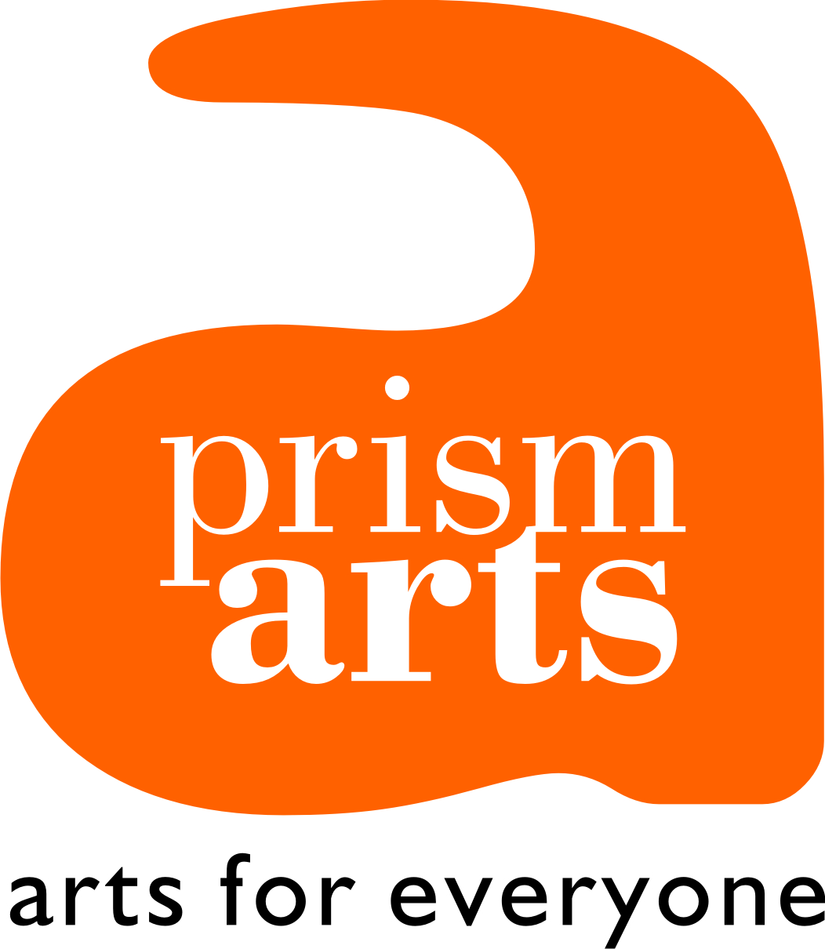

PRISM ARTS BUSINESS PLAN 2015/2020

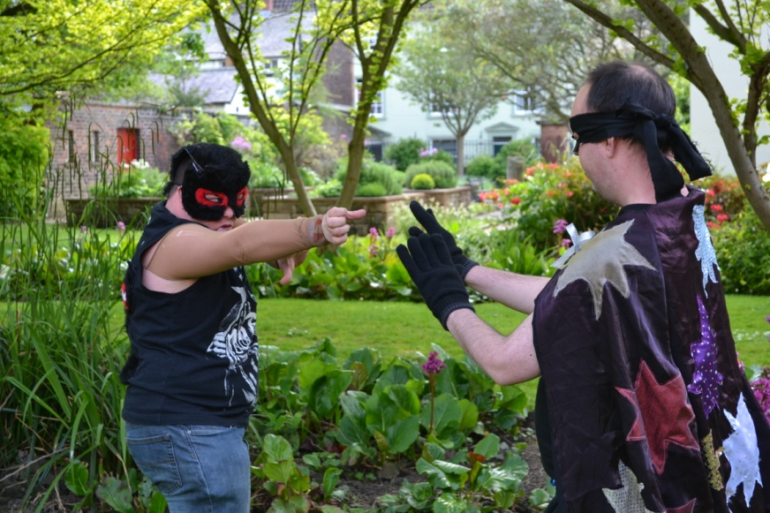

January 2015
PRISM ARTS BUSINESS PLAN 2015/20

Prism Arts Vision
Our vision is a society where everyone can create, access, engage in, experience, and participate in excellent arts practice irrespective of their age, ability or health.

Prism Arts Vision for the future of the organisation:
By 2020 Prism Arts is a resilient organisation with a strong future, recognised by its stakeholders across Cumbria and the northern region (England) as an exemplar arts organisation delivering creative excellence in support of people facing barriers to engagement or participation in the arts.

Prism Arts Mission
Prism Arts Mission is to create opportunities and pathways for people and artists facing barriers to engagement in the arts because of health, age or disability, to realise their full creative potential through active participation and exploration of the arts.

OUR BUSINESS PLAN

- We have excellent people at all levels

- We support a thriving network of artists and have policies in place to support diverse and emerging artists.

- We understand and communicate with our audience, participants and stakeholders

- We are recognised for the quality of our work both regionally and nationally

- We have consolidated and developed strong partnerships and collaborations

- We are part of the established regional and national touring networks

- We have delivered a wide ranging creative programme

- We champion equality, diversity and sustainability

- We plan for a secure and resilient future

Appendices

- Appendix One: SMART Targets 2015/18
- Appendix Two: Creative Programme 2015/16
- Appendix Three: Budget Forecast 2015/18

ONE: We have excellent people at all levels

Prism Arts is committed to supporting, employing and contracting excellent people to help us drive our vision forward. We are committed to promoting great opportunities for disabled people and artists to work in our sector. We will achieve this through:

A: An informed, knowledgeable board with clear roles

- Prism Arts has an excellent board of trustees who champion the work of the organisation, are clear about its vision and have defined roles.

- Trustees will be recruited in line with identified skills and knowledge gaps as identified in the Board Development Plan.

- Each Trustee will be recruited on the basis that they will hold a clear and specific role in support of the organisation and the vision. We will recruit an artist to the board by 2016

- By 2015 A Board Development Plan will have been completed. Trustees take leadership of the creation of a board development plan. Skills gaps are identified. A training plan is implemented.

- Trustees take an active interest in the work of the charity, visiting workshops and performances on a regular basis. Trustees visit the website on a regular basis and read social media, blogs and twitter feeds. Trustees are informed of events.

- Prism Arts is fully inclusive at board level. Meeting venues are always accessible, accessible information is provided. Nobody is excluded from joining Prism Arts board on the basis of age, disability or health. Our priority is to ensure that Trustees have the relevant skills, understanding and expertise to govern the organisation.

- Prism Arts will provide every new Trustee with an induction pack, including information about the business, the sector, health and safety and safeguarding obligations and a Trustee Responsibility document.

- By 2015 Prism Arts is a Charitable Incorporated Organisation (CIO) with updated Board Rules and Constitution

- Trustees actively support the staff team in the audit and revision of policy and other key governance documents.

- By 2018 Prism Arts has an active board of Trustees who champion the work of the organisation.

- The Chair of the Board will appraise the Director on an annual basis.

- Prism Arts Trustees will review risk to the organisation overall on an annual basis and at every board meeting through the Director’s Report. Risk is recorded in a Risk Register.

- Prism Arts will set and review key work objectives every two years. This will allow the organisation to remain vibrant and relevant in a fast changing environment. As part of this process Trustees will review Prism Arts reach at a local, county and regional level.

B: An excellent staff team

- There is regular and appropriate training/development of staff. Prism Arts values its staff and is committed to addressing training and skills development needs. We aim to secure more funds for staff and artist development as the organisation moves forwards.

- Staff have clear roles and defined specialisms but work as a team. Staff work and collaborate effectively across both artistic and operational strands.

- We believe in the development of talent amongst our staff and artist team. The Director appraises staff annually. Training plans are agreed and implemented.

- We appoint new staff strategically and in line with our core mission and vision. Artists are increasingly appointed to the staff team to develop and deliver our creative programme.

- We undertake rigorous recruitment procedures for both permanent and contract staff. We write clear job descriptions, set work objectives and engage trustees in interviews. We pay our staff and artist fairly and in line with good practice.

- We apply the Creative Case: Prism Arts actively works to overcome barriers to full participation in the arts, this includes our approach to recruitment and employment. We actively create opportunities for disabled people and artists to fully access employment opportunities. Prism Arts has a ‘Positive about Disabled People’ kite mark. Our equality statement is posted on our website.

- All staff delivering programmes have appropriate qualifications, excellent skills and expertise. If skills gaps emerge or aspirations to further develop skills and expertise are identified, relevant training is provided.

- Volunteers are highly valued but undertake a strict recruitment process. We aim to find progression routes for our volunteers.

- There are formal HR procedures in place. Currently all staff have contracts and copies of a Prism Arts Staff Handbook. By 2015 Prism Arts will have contracted a new HR support service.

- Staff are fully involved in devising, planning and evaluating the programme. This is achieved through team meetings, bi annual Away Days, bi monthly artist meetings and planning/evaluation meetings.

- Induction is given to all staff, volunteers, and freelance artists. All staff, volunteers and artists working directly with vulnerable people and children have up to date DBS Certificates, in line with our Children and Vulnerable People Policy.

- Health, safety and risk assessment training is provided at induction. Prism Arts is committed to ensuring the safety and wellbeing of staff, volunteers and contract deliverers. Staff receive risk assessment training. Staff and volunteers are inducted into health and safety procedures and safeguarding policies at the start of a contract. Delivery Staff and volunteers receive First Aid in the Workplace Training.

Two: We support a thriving network of artists and have policies in place to support diverse and emerging artists.

By 2020 Prism Arts has enables diverse artists in Cumbria to develop their talent and to realise their ambitions. The Creative Case informs our work to create a level playing field for diverse artists not only to develop their talent but to exhibit and perform their work. We do not accept anything less than full inclusion and equality for all.

We deliver an excellent programme because we have invested in and supported our artists, diverse artist and emerging artists.

We work to enable diverse and emerging artists to access progression pathways, built a strong understanding of the sector and need through research and partnership.

We will achieve this in the following ways:

- Talent Development 1: We support our emerging and diverse artists to showcase their talent and to reach new mainstream audiences: In line with our vision and the Creative Case we will create opportunities for diverse artists to promote their work in Cumbria and across the Northern Region. We do this through:

  - This strand of work is aimed at engagement of diverse artists living across primarily Cumbria and the northern region.
  - We undertake a research project to review existing data around diverse artists working in Cumbria and identify what learning/support is required within the sector.
  - We use this research to inform artist training opportunities with a focus on developing the skills to create successful submissions, understand what commissioners are looking for and defining peer support in partnership with Brewery Arts Centre, Outside In and Tullie House.
  - Sustaining and building partnerships with mainstream cultural organisations to increase opportunities for diverse and emerging artist to show and perform work.
  - Hosting an annual C.Art Gallery in partnership with University of Cumbria Faculty of Art
  - Sustaining partnerships with regional/national inclusive arts organisations.
  - Co delivering an annual commissioning opportunity for diverse artists in partnership with Tullie House Museum and Art Gallery
  - Support a partnership with Outside In and Tullie House to deliver an exhibition promoting the work of diverse artists.
  - Continuing to enter the work of our emerging artists into regional and local competitions.
  - Digital reach showcases talent: Prism Arts website, Outside In and partner organisations web and social media sites.

- Talent Development 2: We will implement our Emerging Artist Policy. A key focus 2015/18 will be to develop the talents and artistic excellence of our participants as emerging artists combining support through core projects with additional artist mentoring; sometimes this will involve enabling emerging artists to use our studio space outside of core projects. Emerging Artists have space on our website to promote their work. There is potential for this strand of work to have wider reach: initially it will be focused on supporting artists from Studio Theatre Carlisle and Studio Theatre West between 2015/18.

- Through both talent development activities: We will explore how we can also support and train our emerging and diverse artists to generate income for their work through winning commissions or become paid workshop leaders as part of their ongoing development.

- We will use digital and new media to reach, inform, connect and promote diverse and emerging artists. This will achieved through:
  - A partnership with Outside In (www.outsidein.org.uk).
  - Web Site: Our Artists and Our Emerging Artists: our website will connect artists and inform the public and stakeholders about their work, including examples of past work and artist statements.
  - All new commission opportunities are promoted to diverse artists living in Cumbria and the region

- We will build volunteer and career progression opportunities across our artistic programme. We continue to create opportunities for artists and graduates to work with us, develop key skills and to become part of our delivery and creative team.

- We are committed to workforce and Continued Professional Development of artists: We are committed to the development of all our artists. We aim to increase the number of artists and diverse artists opting to work with our participant groups to meet the increasing demand for our services. We will support our emerging artists. We will ensure that all our artists are trained as Arts Award Arts Advisors.

- We reach out to other artist networks to promote the work of our artists and emerging artists. Prism Arts Artists will engage with peers in the inclusive arts sector in order to raise the profile of our work, the work of our artists and to measure our success. We will do this by developing closer links with disability and inclusive arts organisations and artists in the Northern Region and Nationally.

- Our Artists shape and inform our creative programme. We hold quarterly artist meetings to review and develop our creative programme. Led by the lead Artist. Emerging artists engage in this work.

- We champion fair pay for our staff artists, freelance artists and diverse artists. We pay our artists on a par with national arts organisations. We support diverse artists to develop the skills to achieve paid work.

- We apply learning and recommendations from the Creative Case: Creating opportunities, bringing new work by diverse artists into the mainstream creating commission and paid opportunities, highlighting excellence, changing perception.

- We have a clear Artistic Statement accessible via our website.

Three: We understand and communicate with our audience, participants and stakeholders

In this section we explore how we will engage our
- participants (people who actively engage in workshops),
- audiences (people who see our work)
- stakeholders (people and organisations who are partners, funders, commissioners)

We will achieve this through:

- Development of an Audience Development Plan for Prism Arts (appendix 1)
  - We apply our Audience Development Plan and Action Plan
  - We are subscribed to Audience Finder: http://www.audiencefinder.org/

- Application of our Marketing Strategy. We will review our Marketing Strategy in 2015.

- We keep clear records and evaluation ensuring that we capture and record data from audiences, participants and stakeholders. We use case studies, excel spreadsheets, questionnaires, Survey Monkey and face to face interviews. We use models that enable us to capture data from participants with communication needs.

- Participants:

We are committed to identifying and reaching new participants who are not currently accessing the arts.
  - We continue to build links with the disability sector, cultural sector, schools and colleges.
  - We continue to host the Carlisle Dementia Partnership
  - We continue to sit on the Bridge Development Group until 2015 for Cumbria currently managed by Creative Futures Cumbria (children and young people)
  - We continue to work with, and offer consultancy to, disability organisations looking to create arts opportunities for their beneficiaries and cultural organisations looking to engage disabled people.
  - We continue to offer taster sessions/pilot projects enabling new participants to experience our work
  - We support the Family Arts Festival and sit on the Cumbria wide steering group.

We are committed to developing stronger and deeper engagement with our existing participants through our core programmes.
- Studio Theatre
- Dementia and Creativity
- Emerging and Diverse Artists

We will have an in depth understanding of the needs of our Participants.
- Through working with disability specialist partners
- Through evaluation and mentoring
- We have skilled and trained staff and artists able to deliver work that meets the needs of our participants.

We engage Participants with an excellent creative programme. Prism Arts has had a long history of delivering excellent work with diverse groups in Cumbria. We will build on this reputation:
- The creative quality of our work is paramount
- Creative excellence enables us to reach and retain participations
- We engage and employ great artists who respond to the needs of our participants
- We respond to the needs of our participants
- We will manage this through robust recruitment and artist selection procedures, artist leadership and planning, training and development of staff and artists, evaluation and monitoring.

- Audiences:

We develop new audience within the disability sector in order to champion and celebrate the work of peers.
- We always invite disabled organisations, schools and groups to attend our performances and events
- We tour work to disability organisations, schools and community groups.

We reach a new mainstream audience by:
  - Developing a new touring model that is taken to mainstream school, cultural and community centres and theatres both in Cumbria and across the region.
  - Develop an annual outdoor promenade model through our Summer School (Carlisle Pageant)
  - Developing new work that is programmed as part of mainstream events and exhibitions (C.Art)
  - Exhibiting work in mainstream and public places (Cumbria Library Service 2015/16)
  - Working with cultural partners we will reach mainstream audiences, as set out in our Audience Development Plan (e.g. Eden Arts C.Art :C.Art marketing enables us to reach this audience, shared evaluation after the event enables us to assess the impact of our work).

- Stakeholders: We understand our stakeholders and engage them with the quality of our work through excellent communication, accountability and consultation:

We understand who our stakeholders are:
  - Parents, carers and participants
  - Cultural and arts sector
  - Funders, commissioners and investors (public, private and third sector)
  - Disability and health sector
  - Brokers and Social Workers

We work with our stakeholders through partnership, commissions, funded work and contracts

We will communicate effectively with stakeholders: We highlight and promote in the quality of our work and practice through:
- The production of excellent evaluation, publicity and information available both through digital formats, social media, print and e-mail.
- Presentations at events and seminars
- direct engagement through meetings
- invitations to events, performances, workshops and exhibitions
- Invitations to feed back to us through a range of evaluation tools (survey monkey, meetings, conversation, and questionnaires).

We demonstrate clear accountability to our stakeholders: We make sure that we maintain clear accountability of all projects and that information and relevant reports are communicated to our Trustees, broker organisations, funders and partner organisations. Much of this information is available on our website.

- We will communicate regularly with Participants, Audiences and Stakeholders:
- We will ensure that we provide clear information about our work.
- We ask people how they would like to receive information and respond to this.
- We produce professional well designed publicity available in print and as downloads from our website and via e-mail.
- We maintain up to date mailing lists and audience data. We keep our website up to date and have allocated resources to maintain our digital and social media sites.

- We will make good use of the website and social media platforms to disseminate our work to our audiences, participants and stakeholders.
- We will ensure that relevant project information including leaflets and evaluation reports are available through our website as downloads.
- We will consistently review and refresh the website to ensure that is it acting as an excellent ‘shop window’ for our work and the work of our artists.
- Project specific work is up to date and relevant.
- We engage our audience with regular postings on social media and our blog
- We engage audiences with work of our artists, our emerging artists through both our website and through posting their work on Outside In (www.outsidein.org.uk).

- We will engage with and promote our work to participants, audiences and stakeholders across Cumbria, in line with resources: We will be ambitious but realistic, exploring innovative ways to engage across a wider area.

Four: We have raised our profile locally, regionally and nationally through communication and collaboration.

Our vision is to raise the profile of our work across Cumbria and the Northern Region. We feel that the next phase of our work can also enable Prism Arts to develop a voice nationally as part of wider collaborations and partnerships.

In order to do this we will:

- Work effectively as a team because internal communication is paramount
- Apply our Marketing Strategy (refreshed 2015)
- Communicate with participants, audiences and stakeholders as set out in Section Three.
- Communicate Prism Arts purpose and successes locally, regionally and nationally through digital media, press and our website
- Focus on excellence and our specialist status in order to raise our profile and meet our vision.
- Improve engagement of health and social care stakeholders including brokers, carers and parents with core projects. By 2018 Prism Arts will have increased referrals to our work.
- Work in partnership and develop opportunities to communicate our good practice in collaboration. By 2017 we will co-host a seminar with Tullie House exploring outcomes of our Dementia and Creativity programme.
- Use our evaluation findings, case studies and blogs to celebrate our achievements and the achievements of our participants via our website and social media.

We will be recognised for the quality of our work both regionally and nationally

- We will champion the fact that Prism Arts are the only arts organisation in Cumbria/ North West to have succeeded in developing an arts project funded by individuals through direct payments. This is currently recognised at a national level through Arts Enterprises in Health and Social Care Group in London.
- Through our work advocating for arts opportunities for all we are recognised as leader in our field. We use digital media, blogs and case studies to celebrate achievements.
- We deliver a conference/festival highlighting the work of diverse artists and work within our specialist fields: Learning Disability and dementia
- Untapped Potential (training for care workers) has developed a regional reputation by 2018
- We only deliver excellent work led by professional artists; the quality of our work underpins our vision.
- We continue to sit on local and national groups and networks to share good practice.
- Our reach expands beyond Cumbria through partnership and collaboration with organisations including Outside In and TinArts.
- We support the Creative Case events with an emphasis on activity around Creative Case North. We have been invited to attend Creative Case North steering committee and have explored undertaking Creative Case pilots in partnership with mainstream cultural arts organisations (Brewery Arts Centre/Tullie House).

Our creative programme and touring strand enables us to reach new areas of the country
- We tour our work to raise our profile and the profile of our participants and artists and to expand our reach across Cumbria.

Five: We have consolidated and developed strong partnerships and collaborations

Prism Arts will continue to collaborate with a wide range of partners to improve access to the arts for people experiencing barriers to engagement because of health, age or disability. Collaboration will help to strengthen our programme, enable us to develop new projects, allow us to support existing projects and to sustain our work, beyond 2020.

We will prioritise partners who enable us to address our vision and mission and are committed to working collaboratively.

We will achieve this through:

1. Understanding who our partners are and how to engage them:

1.1 We will work with disability and specialist organisations to promote inclusion, engagement and participation in the arts

- We will engage these partners and their beneficiaries with excellent inclusive arts practice and opportunities to see new work.
- We will learn from working with sector specialists who understand the needs of the people they exist to support
- We will continue to build relationships and commissioning opportunities with specialist disability organisations to support development and delivery of a sustainable arts programme (2015/16 Cumbria Cerebral Palsy)
- We will develop one health and arts project with North Cumbria University NHS Hospitals Trust
- We will actively encourage partners to build Arts Award into projects. We will work to progress young people and children through the Arts Award categories.

Partnership Examples: Specialist Organisations
- Specialist organisations supporting a specific area of need: Alzheimer’s Society, Cumbria Cerebral Palsy, Age UK
- Residential homes and Day Centres for learning disability and older people: Cumbria Care including Dowkers Lane Kendal, Ella Thompson and Langrigg House in Carlisle
- Schools that deliver special educational needs (SEN) services: James Rennie School, Mayfield School and mainstream schools with specialist support units.
- Health prevention: Memory Clinics, CCG/NHS in Cumbria, North Cumbria University NHS Hospitals Trust, Adult Social Care Cumbria County Council

1.2. We will work with Arts and Cultural Organisations:

- Use our knowledge and expertise to support mainstream arts and cultural organisations to reach new diverse audiences and participants.
- Collaborate to develop opportunities for diverse artists to access mainstream art galleries. For example creating opportunities for diverse artists to apply for commission and exhibition projects at Tullie House.
- Collaborate with arts organisations with specific knowledge around working with a group of people or art form specialism. For example Haltwhistle Film Project, Dance Recall, New Arts North.
- Collaborate with other regional and national inclusive arts organisations to share good practice and expand our reach.
- Collaborate to develop new touring work or exhibitions to engage mainstream audiences with our work and the work of our diverse artists. For example Outside In exhibitions.
- Connect mainstream arts organisations with the work of national and regional diverse artists and disability arts organisations.

Between 2015 and 2020 we will work with:
- Tullie House Museum and Gallery: Carlisle
- Kirkgate Centre: Cockermouth
- Rosehill Theatre: Whitehaven
- Theatre by the Lake: Keswick
- Brewery Arts Centre: Kendal
- Cumbria Library Service: Carlisle and Penrith
- Haltwhistle Film Project: Northumberland
- Eden Arts/ C-Art: :Penrith
- Carlisle City Council Arts Development Service: Fire Station Arts Centre: Carlisle Pageant
- TinArts: Durham
- Venture Arts: Manchester

2. We will prioritise partnerships and collaborations that enable us to engage the following groups with excellent arts opportunities:
- Learning Disability and Autism
- Young disabled people
- Older people, especially people with dementia and stroke
- Health and mental health

3. We will maintain strong strategic partnerships with cultural, community and local agencies in support of our work and to promote inclusive arts practice.
- Disability and Specialist Networks: Cumbria Third Sector Consortium, Cumbria Care Sector Alliance
- Older people: We will continue to host: Carlisle Dementia Network (comprising arts and specialist organisations and NHS) We continue to host the Cumbria Cultural Dementia Calendar on our website: http://www.prismarts.org.uk/cultural-dementia-diary/
- Children and families: Family Arts Network
- Children and Young people: Cumbria Bridge Development Group (currently facilitated by Creative Futures Cumbria) We will build Arts Award into all relevant projects.
- Learning Disability: Learning Disability Partnership Board: Aim to join by 2015.
- Health and Arts: Arts Enterprises in Health & Social Care Group in London (facilitated by the Rayne Foundation)
- Strategic: Cultural Commissioning: We will work to engage the Local Authority in support of commissioning of the arts, with a focus on Adult and Social Care Services. We will sustain links with NCVO Cultural Commissioning Programme. Staff will receive relevant training.
- A leadership role within a New Arts and culture Network for Cumbria: Lining arts organisations to health and commissioning opportunities. Supported by CVS, Cumbria County Council, Cultural Commissioning/New Economics Foundation (NEF)

Six: We are now part of established regional and national touring networks

By 2020 Studio Theatre is an exemplar learning disabled touring theatre company producing original new work that is toured to mainstream theatres, festivals, schools and community venues across Cumbria, regionally and nationally.

By 2020 Prism Arts is part of the established regional and national touring network and championing the work of diverse and emerging artists.

- An application to Arts Council Strategic Touring Fund enables Studio Theatre enables Prism Arts to develop our existing touring model. A partnership arts organisation with strong promotion expertise will be indentified: Rosehill Theatre or Brewery Arts Centre.
- Toured/exhibited work extends our reach across Cumbria and the Northern Region
- By 2020 Studio Theatre is recognised as an exemplar touring Learning Disabled Theatre Company working across the region
- Our Summer School enables young disabled people to created new outdoor promenade work for Carlisle Pageant
- New and existing venues and locations are engaged and start to programme our work on a regular basis
- We focus on Visual and Performing Arts
- We engage with both disability arts events and mainstream arts festival and events.
- We record and promote our work and through our website and social media sites
- Every year from 2015 Prism Arts successfully tours Studio Theatre productions to locations in Cumbria and from 2018 to locations outside the county.
- We invite stakeholders, new audiences and peers within the disability sector to review and comment on our work
- We will explore the development of new touring work that celebrates our work with older people

Seven: We have delivered a wide ranging creative programme

The key priorities of our creative programme 2015 – 2020 will be:

- Artistic Excellence is our top priority. We embed artistic excellence throughout our programme
- Our creative programme is managed and delivered by skilled, experienced and excellent professional artists
- Artists and participants (emerging artists) shape and develop our programme.
- We secure and prioritise our core creative projects and develop new work for exhibition and tour (section Six)
- We develop new partnerships and attract new commissions in order to reach new audiences and participants in line with our vision and mission (Section 3 and 5)
- We are recognised for the quality of creative programme both regionally and nationally.
- Our creative programme is accessible via our website: www.prismarts.org.uk
- We always explore opportunities to exhibit and share the work of our participants and emerging artists through working with mainstream cultural organisations and engaging in county wide events, programmes and festivals
- We will actively build Arts Award into all relevant projects. We will work to progress young people and children through the Arts Award categories.
- Our programme always creates opportunities for diverse and emerging artists
- Workshop delivery of core projects is focused in North and West Cumbria
- We will tour work across Cumbria and the region
- Trustees agree the creative programme on an annual basis.

- We maintain and develop the core projects that work well:
Core projects allow us to deliver depth, excellence and quality of engagement.
Studio Theatre: Theatre and Visual Arts Programme for people with Learning disability and Autism funded by individuals through Direct Payments

- Focused delivery in North and West of the County
- Studio Theatre participant numbers are maintained and expanded. The project continues to be self sustaining through direct payments.
- By 2020 Studio Theatre West is breaking even through income from direct payments.
- Studio Theatre is promoted as a success story and develops into an exemplar theatre company developing and touring new work
- Studio Theatre builds in opportunities for participants to progress both as artists and through opportunities like Arts Award.
- Both core projects create opportunities for people to develop as artists and join our Emerging Artist Programme
- We embed opportunities for young disabled people across the programme and deliver Arts Award.
- Free transition placements (age 14 – 18) enable young disabled people to access Studio Theatre before leaving school or college.
- Free taster sessions allow people with learning disability and autism to try the project before they sign up
- Artists and participants drive the programme

http://www.prismarts.org.uk/learning-disability/studio-theatre/
Creativity and Dementia: Creative Arts programme for people with stroke and dementia

- Concentrate on building weekly delivery in Carlisle, developing a sustainable group that is attracting referrals from a range of NHS services and social services.
- BY 2018 we have developed an innovative creative model for work with older people and dementia that is recognised across the region.
- A PhD working with University of Lancashire Centre for Aging has evidenced the impact and benefit of older people engaging in participatory arts.
- Artist and participants drive the programme. Participants develop as artists.
- We will explore opportunities to develop a piece of touring work: A Theatre of Memory
- Focus on excellence

http://www.prismarts.org.uk/older-people/creative-workshops-for-people-with-dementia/

Untapped Potential: A training programme enabling care and support workers to develop creativity and communication skills delivered in partnership with Haltwhistle Film Project.

- Untapped Potential achieves a listing on the Cumbria County Council Training Providers Framework by 2016
- By 2018 Prism Arts/ Haltwhistle Film Project is working in partnership to deliver at least 1 Untapped Potential training programme per annum
- Untapped Potential underpins our specialist status and profile
- Creates opportunities for our work to reach across a wider area through time limited focussed training projects commissioned by council managed day centres (adult social care) and charities.

http://www.prismarts.org.uk/training/care-workers/untapped-potential-setting-free-the-support/

- Our Programme enables us to create opportunities for new participants to experience and engage in the arts:
- Pilot projects and commissions. To include pilot projects, focussed consultancy support and advice for disability, cultural and organisations working with young disabled people, including schools
- We will offer consultancy to explore how arts projects can be developed. This might involve a short pilot project, offering advice and support to fundraise for future work.
- We will deliver an annual Summer School for young people with learning disabilities. We will build Arts Award into this project.

- Our programme allows us to sustain, attract and deliver new commissioned work
- Carlton Day Centre: We continue to deliver an annual commissioned programme for Cumbria County Council Carlisle Day Services, working with people with profound and multiple disabilities
- We continue to submit tenders for commission opportunities as long as they meet our vision and mission and enable us to reach new participants and audience.
- Untapped Potential is an exemplar training programme that is commissioned by a range of third sector and public sector organisations.

- Artists meet regular to shape and develop our programme. We believe in placing artists at the heart of our programme to ensure innovation and excellent practice.

- Our creative programme always explores opportunities for our participant’s work, the work of our diverse artists and emerging artists to engage with a wider mainstream audience.
We actively seek to break down barriers to audiences accessing the work of diverse artists and our own work. Our strategy is to link our programme with larger country wide cultural opportunities. We will continue to exhibit work within our own spaces in Paternoster Row, through C-Art (Eden Arts), Outdoor Festivals, Tullie House Museum and Art Gallery, within Schools and Colleges, Libraries and Theatres.

- We work effectively across Cumbria and the Northern Region but in line with our resources:
This is reviewed by Trustees on an annual basis through the Creative Programme.
- Core projects deliver weekly creative workshops within North and West Cumbria.
- Carlisle is both a spring board and centre for excellence for core projects.
- Short pilot projects/ residencies across Cumbria allow us to work with new participants and disability organisations/day centres/cultural organisations. Consultancy support enables organisations to explore how they might sustain pilots.
- Development of a new touring theatre strand will allow us to reach across Cumbria and develop new audiences.
- We create opportunities to share learning with other arts, health and disability organisations across Cumbria: 1. Direct Payments (Studio Theatre) 2. Inclusive arts practice and participation. 3. Dementia and Creativity
- We work in partnership with arts organisations based across Cumbria and the region enabling us to deliver across a wider geographical area.
- We use digital and new media platforms to reach across Cumbria.
- Maintain links with Diverse Artists living in Cumbria, ensure that artists are listed on Outside In and that they are always invited to participate in open selection opportunities (Tullie House Museum and Arts Gallery Carlisle/ Open Up North, Brewery Arts Centre Kendal)
- Engage with county wide or regional arts opportunities: C-Art and Open Up North
- Work to our strengths, rather than spread our resources too thinly across a large area.
- County wide delivery is properly resourced through funded and commissioned work
- Untapped Potential training programme allows us to work across Cumbria and Northumberland.

Eight: We champion equality, diversity and sustainability

- Diversity Policy Statement
Prism Arts welcomes diversity as part of our belief that “arts are for everyone”. A better understanding of people’s differences helps us to appreciate and value everyone’s contribution, and recognise that we are all an integral and invaluable part of our Society.

Everyone has the right to be treated with consideration and respect. Our organisation is committed to achieving a truly inclusive environment for all, by developing better working relationships that release the individual’s full potential and creativity in an atmosphere where everyone can learn and work free from prejudice, discrimination, harassment and violence.

Prism Arts aims to support and engage with individuals who have a learning or physical disability, or who are older members of our society experiencing isolation or age related health problems.

Prism Arts aims to ensure that all staff, volunteers, partners, clients, artists and the general public are treated fairly.

- We believe in Arts for Everyone
This is underpinned by our mission and vision

- We will rigorously apply our Diversity and Equality Action Plan and review it annually.

- We are committed to environmental sustainability and apply our Sustainability Action Plan

- All our policy documents are available on our website and are monitored annually.
Including Children and Vulnerable People

- We apply the Creative Case* across our organisation, across our programme and used this model to review our mission and vision in 2014. We will work across our programme and our organisation to ensure that individuals and artists facing barriers to inclusion in the arts because of age, disability or health find routes to engagement in the arts. We will actively seek to develop partnerships and opportunities to increase opportunities for diverse artists locally and regionally, support our emerging artists, work to engage new mainstream audiences and ensure that resulting work is exhibited and performed within mainstream venues and theatres. We will use our partnerships and networks to create these new opportunities for diverse artists. We will develop training opportunities and digital engagement opportunities for diverse artists to network and develop skills to access mainstream arts opportunities. We have built Creative Case and new opportunities for diverse artists throughout our business plan and will monitor our progress through SMART Targets (Appendix 1).

For example we will use C-Art as a county wide opportunity promoting the work of diverse artists through our Gallery delivered in partnership with University of Cumbria. In 2014 Prism Arts attracted more audiences to our C-Art Gallery promoting the work of diverse artists alongside mainstream Fine Arts graduate than other Carlisle based C-Art Galleries. We will be a C-Art Hub in 2015.

- We will deliver leadership in this area within Cumbria. We will work with partners to promote diversity and the Creative Case. We will work to create new opportunities for diverse artists to participate as part of mainstream cultural offer. We will use Creative Case Dialogue opportunities to move our conversations forwards with organisations like Tullie House Museum and Art Gallery.

* http://www.artscouncil.org.uk/media/uploads/pdf/What_is_the_Creative_Case_for_Diversity.pdf
Nine: We plan for a secure and resilient future

We work effectively with the resources we have, but there is always room for more because resilience is also about building relationships, partnerships and collaborations.

- We ensure the financial sustainability of current projects and have secured income for Studio Theatre
- We continue to attract investment from trusts, foundations, public sector and donations
- We explore commissioning and tendering, including new opportunities emerging around the health prevention agenda.
- We actively seek partnerships and collaborations to develop new opportunities.
- We monitor and evaluate our work; we undertake self assessments to improve our work.
- We are financially resilient. We are clear about what income we secure, and why
- We take up new opportunities but only if they are fully resourced
- We charge the right price for our work.
- We work smartly and creatively with the resources available to us

- To do this we aim to work within the following key financial guidelines:

- Prim Arts will ensure that the income and expenditure budget remains balanced on an annual basis.

- Ensure that funding/ earned income always includes between 20% and 30% towards operational costs for commissioned work, 30% for work funded by trusts and foundations/lottery (in funding bids this will be broken up into constituent parts – comprising staff resource costs, travel, core and evaluation costs)

- We will apply our Fundraising and Income Generation Strategy
- Priority 1: Build on success and existing expertise to secure the future
- Priority 2: Balance resource and expertise against likely return

- We will actively seek new and continuation funding from:

- Arts Council and Lottery
- Commissions from cultural and disability organisations
- Local government and the public sector via tenders, grants or commissions
- Trusts and Foundations
- Charitable donations and individual giving

- We will look to generate income through the following activities (within charity commission guidelines):

- Increase income through winning commissions and contracts both independently and in partnership.

- Develop Studio Theatre: Our direct payments funded strand
  - By 2020 Studio Theatre is a fully sustainable strand in both Carlisle and west Cumbria

- Increase income by charging for some services:
- Participants pay to attend workshops
- Untapped Potential: Care and Support worker training developed in partnership with Haltwhistle Film Project.
- In depth consultancy and advice (over and above standard advice and support services funded by the Arts Council of England)
- Transition placements for young disabled people 14-18yrs

- Ensure sufficient core funding is secured to maintain Prism Arts. We will pursue funding opportunities that enable us to secure core funding. This will include working with regular core funders from the public sector (Arts Council and Cumbria County Council) , and exploring new funding from the lottery, trusts and foundations that are specifically targeted at supporting core costs (ref no. 1.3 Section 9). We will also look into attracting core funds generated from charitable donations.

- Continue to explore tendering and bidding partnerships with a range of organisations and organisations:
- Maintaining membership of Cumbria Third Sector Bidding Consortium (C3C)
- Supporting the development of a County Arts Network, led by CVS enabling arts organisations to engage commissioners (health and public sector)
- Continue to work with other arts organisations to secure tendered and commissioned work.
- Continue to engage with the Local Authority around Cultural Commissioning and tendering

- Maintain good relationships with funding organisations. In line with our Funding Strategy, We will aim to sustain good relationships with existing funders and supporters of our work with a view to achieving continuation funding. Build new relationships with larger trusts to preplaced lost income as a result of the closure of Northern Rock Foundation.

- Investment policy for reserves: We will develop a safe and secure investment policy for our reserves that is appropriate to our needs and allows us the flexibility to access funds quickly if required (as per our reserves policy). This policy will be agreed and managed at Board level.
- Review the organisational structure to ensure that we are best placed to respond to the external financial environment. From 2015 Prism Arts will be a charitable incorporated organisation (CIO), with a revised constitution and new board rules.
- We will undertake clear monitoring and evaluation of our work across the whole organisation to ensure resilience. In order to do this we will:
- Keep clear records of quantitative and qualitative information, data and monitoring.
- Keep strong accounts so that we can track financial progress
- Undertake self assessments to ensure the health of the organisation.

